Cone followmeter
Overview
The product has two measurement types: basic type and integrated temperature and pressure compensation. The basic type measures the flow signal of a single working condition. The integrated temperature and pressure compensation can measure temperature, pressure and flow signals at the same time, and output the standard volume flow or mass flow after compensation. . The product has two structural types: pipeline type and plug-in type, which can be displayed on site or transmitted over long distances. Each type has specifications for high temperature, high pressure, anti-corrosion, and explosion-proof to adapt to different measurement media and installation environments.
The instrument has a series of advantages such as no moving parts, high measurement accuracy, convenient installation and maintenance, and wide media adaptability. It can accurately measure clean or dirty fluids under the condition of a shorter straight pipe section and a wider range ratio. It can be widely used in process measurement in the fields of petroleum, chemical, electric power, metallurgy, municipal administration, papermaking, medicine, etc. And energy-saving management.
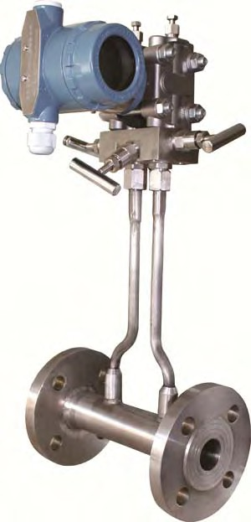

Basic structure

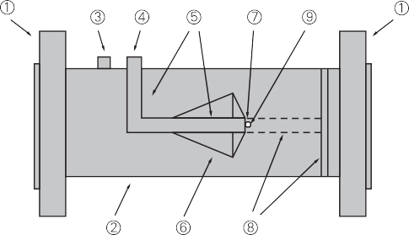

- Flange ②Measuring tube ③Positive (high pressure side) pressure tapping hole ④Negative (low pressure side) pressure tapping hole
⑤Negative pressure measuring tube with front support ⑥Cone ⑦Negative pressure measuring port ⑧≥DN150 with this rear support ⑨Negative pressure measurement Hole (open this hole when there is a rear support)

Measuring principle
Taper flowmeter is also a kind of differential pressure meter. It has the same principle as other general differential pressure flowmeters. It is based on Bernoulli's law of mutual conversion of energy in closed pipelines. In the case of a stable flow field, the flow velocity in the pipe is proportional to the square root of the differential pressure. Using the fluid continuity equation and Bernoulli equation, the mathematical relationship between the measured flow rate and the output differential pressure can be derived. The flow formula is as follows :

-Equal effect diameter ratio
-Pipe inner diameter
-Maximum outer diameter of V-shaped cone
-Volume flow
-Density under fluid conditions
-constant
-Gas expansion coefficient

Features

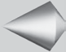Remodeling velocity curve
Reshape the streamline curve is the biggest characteristic of cone flowmeter, to understand the characteristics of the cone flowmeter, must first understand the characteristics of the pipeline fluid flow velocity distribution If no obstacles and interference in the pipeline, can form the ideal flow field Ideal flow in pipeline centerline slit pipeline, the flow velocity for outside: tube near wall flow velocity is almost zero, and the center of the pipe flow rate will reach maximum
Cone flowmeter throttle pavilion body suspension force in the center of the line pipe flow medium around the pavilion in the center of the body, the cone will directly contact with the high speed fluid area, with the high speed zone Hugh blended with near wall zone at low speed ring to change the current curve in the pipeline, the flow uniformity, can fully meet the requirements of the Bernoulli&apos;s theorem, to obtain high measurement precision and repeatability.
Slow
Fast
Mix and flow evenly
Slow

Low requirements for straight pipe sections
The vast majority of straight pipe flow meter is required before and after a long enough, the purpose is to make the flow of the fluid full development ideal state, in the real conditions, the flow velocity is difficult to even, outside a lot of things will cause uneven distribution of fluid, such as elbow, valve, reducing, hole diameter, pump, etc, for other instrument, this is a very difficult problem, and the cone flowmeter using the pin body to reshape the velocity distribution curve Make the cone "rectification" of fluid after uniform cloth, don&apos;t need a long straight section of the rectifier.

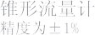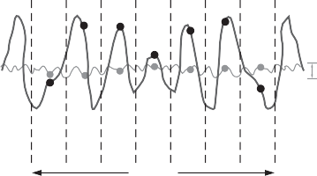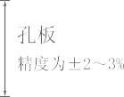High precision and good repeatability
The positive pressure hole of the conical
Orifice

The accuracy is
flowmeter is taken on the pipe wall
upstream of the dimensional body, and
cone followmeter

the pressure position is selected in the
Accuracy
constant velocity region of the ideal
fluid, which conforms to Bernoulli theorem
and the positive pressure signal is stable.
Center negative pressure at the end of
the cone hole, the smallest region lies squarely in the downstream pressure, due to the cone center symmetrical structure,the cone tail center area flow field is relatively static, fluid after throttlingin negative pressure zone appears only high class low-rising small vortex, makes the negative pressure wave signal is very small, very stable output differential pressure signal, the sensor signal is better than reading plus or minus 0.5%, repeatability is plus or minus 0.1%.

Low pressure loss, wide range ratio
Cone flowmeter range ratio of 10:1, usually up to those days, because there is no sharp edge, permanent pressure loss caused by constant d shape flowmeter and than small plate In all of the differential pressure flow meter, only the pressure loss and the meaning of venturi tube cone flowmeter At the same time, extremely stable signal that the differential pressure range lower limit is far less than the average differential pressure flowmeter, so to expand to the lower limit range, low Reynolds number to 8000 can keep the signal is linear

Resistant to pollution, not easy to block
Another major feature of the cone flowmeter is the self-purging structure design, no residual dead zone, the medium will be accelerated when flowing through the cone, continuous erosion of the positive pressure hole, the outer wall of the cone, the wall of the tube near the cone, and the negative pressure hole is isolated by a small section of non-flowing medium, dirty impurities can not enter. Therefore, conical flowmeter can be used for a variety of impurities, easy to crystallization of dirty media. Such as coke good gas, blast furnace gas and other media.
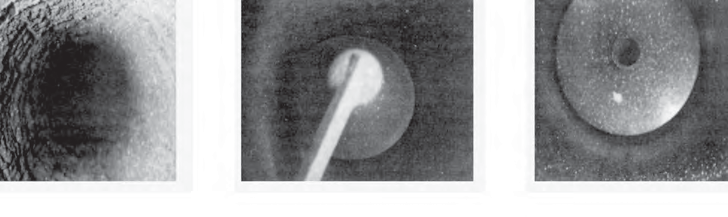 The picture shows the coke oven gas conveying pipe, which is covered with a lot of dirt at night. The conical flowmeter is installed on the pipe for flow measurement.
No scaling at the
back of the cone
No fouling on the front part of the cone
Coke oven gas
pipeline fouling
It can measure high temperature and high pressure medium
Conical flowmeter and orifice plate and other throttling devices, the working temperature and pressure depends on the material and grade of pipes and flanges, working temperature up to 500℃, the maximum pressure 32MPa. If special structure material is used, the temperature and pressure can be higher.

High reliability, good long-term stability
The differential pressure device of the conical flowmeter is simple in structure, strong and durable, and the supporting differential pressure transmitter technology is mature, stable and reliable. The shape design ensures that when the fluid flows through the cone, it is a gradual process without mutation. The fluid reaches the edge of the cone after passing through the energy body, so the edge of the cone will not be frequently worn by the unclean fluid. The B value can remain unchanged, so there is no need for repeated calibration to ensure long-term accurate measurement.

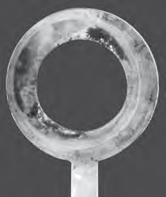

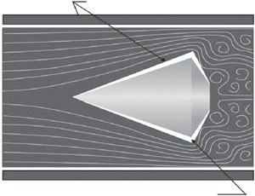

After a period of use, the edge of orifice
plate is easily damaged, resulting in the
change of B value.

Large scale differential pressure
Conical flowmeter scale differential pressure is large, and can be flexibly selected in power plant wind measurement, steel plant gas measurement and other low velocity occasions, its scale differential pressure is all kinds of uniform velocity tube, Venturi, bend tube 10-15 times, can really ensure the stability and accuracy of measurement.

Strong adaptability, can measure the medium of complex working conditions
Because of throttle body structure, in particular by flow liquid property, working condition and site environment adaptability is strong, can not only high precision measurement of general fluid to clean, can also measure high viscosity fluid, high humidity, gas containing solid particles in the fluid and other cleaning fluid, and can adapt to high temperature and high pressure, low temperature, low pressure and bad environment, such as strong vibration conditions.

The design calculation is more accurate
An important design parameter in the design calculation of differential pressure flow meters is the pipe diameter "D", for other differential pressure flow meters.
"D" is the inside diameter of the piping; For conical flowmeters, "D" is the inside diameter of the meter. We know that the size of the pipe is usually marked by the nominal value, and the pipe products are organized according to the outside diameter and wall thickness series, different wall thickness can lead to the same series of pipe diameter difference up to 10 millimeters,this gap can be ignored when designing pipes. If this gap is ignored in the design of the instrument, the accurate calculation is not accurate, and the conical flowmeter "D" is the precise processing value in the production, and the design calculation is more accurate.
Precision machining
size

Technical Parameters

Nominal diameter | Flange mounting type: DN25~DN50  Flange connection type : DN50~DN1500  Pipe butt welding type : DN50~DN2500  Fixed plug-in type, ball valve plug-in type: DN200~DN2500
Temperature range | -50℃ ~ 500℃
Pressure specification | 1.6MPa, 2.5Mpa, 4.0Mpa,. 6.4Mpa higher pressure specifications can be customized special
Applicable medium | Applicable to almost all liquid, gas and steam media
Accuracy | Liquid: ±0.5% of the indicated value;  Gas, steam: ±1.0% of the indicated value;  Fixed plug-in type, ball valve plug-in type: ±2.5% of the indicated value
Repeatability | ±0.1%
β value range | 0.45 ~ 0.85
Range | Normal range 1:10, extended range 1:20
Reynolds number range | 8 × 10 ³ -1 × 10⁷ , the upper limit may be higher, the lower limit may be lower.
Straight pipe requirements | Upstream 0-3D, downstream 0-1D
Instrument material | 1Cr18Ni9Ti, SUS316, 20# steel, alloy steel or other special materials required by users
Environmental conditions | Ambient temperature: Ordinary type -30℃ ~ 60 ℃ Explosion-proof type -20℃ ~ 50 ℃ Field display type -10℃ ~ 50℃ Ambient humidity: relative humidity 5% ~ 85%  Atmospheric pressure: (86 ~ 106) KPa
Explosion-proof mark | Flameproof ExdⅡBT5 Intrinsically Safe ExiaⅡCT5
output signal | 4-20mA (with HART or RS485 communication available)
Supply voltage | 4 ~ 20mA. DC current output type +24VDC field display type instrument comes with 3.6V lithium battery

The main dimensions of the product

Nominal diameter DN | Instrument length L | Connection size C | Nominal diameter DN | Instrument length L | Connection size C
DN15 | 200 | M12×1.25 | DN 350 | 750 | M20×1.5
DN20 | 200 | M12×1.25 | DN 400 | 800 | M20×1.5
DN25 | 200 | M12×1.25 | DN 450 | 900 | M20×1.5
DN32 | 250 | M12×1.25 | DN 500 | 1000 | M20×1.5
DN40 | 250 | M12×1.25 | DN 600 | 1100 | M20×1.5
DN50 | 300 | M20×1.5 | DN 650 | 1200 | M20×1.5
DN65 | 300 | M20×1.5 | DN 700 | 1300 | M20×1.5
DN80 | 350 | M20×1.5 | DN 750 | 1400 | M20×1.5
DN100 | 400 | M20×1.5 | DN 800 | 1500 | M20×1.5
DN125 | 450 | M20×1.5 | DN 900 | 1600 | M20×1.5
DN150 | 550 | M20×1.5 | DN 1000 | 1800 | M20×1.5
DN200 | 650 | M20×1.5 | DN 1200 | 2000 | M20×1.5
DN250 | 700 | M20×1.5 | DN 1400 | 2200 | M20×1.5
DN300 | 750 | M20×1.5 | DN 1600 | 2400 | M20×1.5
Note:
- The above parameters are only applicable to flange-connected cone flowmeters with pressure specifications below 2.5MPa.
- The length of the meter is the standard size, and the length of the meter with integrated temperature compensation is correspondingly extended by 50mm.
- The flange connection type conical flowmeter is not equipped with pipe flanges and bolts when it leaves the factory. The user needs to purchase it separately. The standard of the connection flange is GB/T9119-2000 raised panel flat welded steel pipe flange.
Description:
1. The above dimensions are only for reference when designing and selecting, and the actual dimensions are subject to confirmation at the time of delivery or ordering.
2. The diameter of commonly used seamless steel pipes is the diameter of metric steel pipes. If inch steel pipes are used, they must be specified when ordering.
3. The structural dimensions of pipe butt welding type, flange clamping type, fixed plug-in type, ball valve plug-in type, and square pipe type and jacket insulation type are subject to confirmation when leaving the factory or ordering.
4. The installation flange of the flowmeter adopts the corporate standard or the national standard GB/T9119-2000, and can also adopt other national department or industry standards, or adopt other national standards (American standard, German standard, Japanese standard, etc.) according to user needs, such as If you need special standards, please indicate when ordering.

Models and specifications

Cone flowmeter type spectrum |  |  |  |  |  |  |  |  |  |  |  | Description
HLV | Cone flowmeter |  |  |  |  |  |  |  |  |  |  | Instrument type
 | 2  3  4  5  6 | Flange connection  Pipeline Butt Welding  Flange Clamping Type  Fixed Plug-in  Ball Valve Plug-in Type |  |  |  |  |  |  |  |  |  | Installation method
 |  | 2  3  4  5 | Liquid gas  vapor  Gas (vapor) liquid two-phase medium |  |  |  |  |  |  |  |  | Measuring medium
 |  |  | -X | The nominal diameter of the flowmeter is expressed by 2-4 Arabic numerals, for example: DN200 is expressed by 200 |  |  |  |  |  |  |  | Nominal diameter
 |  |  |  | -2  -3  -4 | The measuring tube, throttling parts and flanges are all made of stainless steel  The measuring tube and flange are made of carbon steel, and the throttle is made of stainless steel and other special materials required by users |  |  |  |  |  |  | Instrument material
 |  |  |  |  | 2  3  4 | Thread pressure (M20×1.5, or according to user requirements ) Socket pressure (Φ14, or according to user requirements)  Flange pressure (Φ40, or according to user requirements) |  |  |  |  |  | Pressure taking method
 |  |  |  |  |  | 2  3  4 | Not supporting differential pressure transmitter,  supporting differential pressure transmitter  Supporting multi-parameter differential pressure transmitter |  |  |  |  | Supporting differential pressure transmitter
 |  |  |  |  |  |  | -2  -3  -4  -5 | -50℃～0℃  0℃～80℃  0℃～300℃  0℃～500℃ |  |  |  | Medium temperature
 |  |  |  |  |  |  |  | 2  3  4  5 | 1.6 Mpa  2.5 Mpa  4.0 Mpa  Higher pressure specifications |  |  | Medium pressure
 |  |  |  |  |  |  |  |  | PT PT | Pressure compensation type Temperature compensation type  Temperature and pressure compensation type |  | Compensation type
 |  |  |  |  |  |  |  |  |  | G  B  N  F  R  H  X  S  L  J  D  YC | Flameproof  Intrinsically safe explosionproof Corrosion-resistant  Square tube type  With RS485 communication  With HART communication, Battery-powered type  Requires flaw detection  With a mating flange  Jacket insulation type  With heating device  Integrated compensation type  With self-purge device | other options
HLV | 2 | 4 | -80 | -2 | 3 | 3 | -4 | 2 |  | B | Flanged tapered flow meter, measured steam temperature is lower than 300 deg.] C steam, the measuring tube, throttle, are stainless steel flanges, DN80, PN16, with a differential pressure transmitter, intrinsically safe.

Selection
The selection of the cone flowmeter can be carried out in accordance with the instrument type spectrum. First, you need to obtain detailed and accurate process parameters. You can refer to the flowmeter selection specifications of each design institute, and then use the software to calculate the process parameters, and confirm the installation The selection of the instrument can be completed by parameters such as method, measuring medium, nominal diameter, instrument material, pressure taking method, medium temperature, medium pressure, and other types. The specific selection method can refer to the following:
1. The choice of installation method
Flange connection is the preferred installation method and is suitable for most applications. The connection flange standard is GB/T9119-2000. If you need to use special standards, please indicate when ordering.
Flange mounting type is used to measure the flow of medium in small-diameter pipes, with compact structure and easy installation.
Pipe butt welding is mostly used for high temperature and high pressure media, instead of flange connection, direct welding is used to reduce leakage points on the pipeline. Fixed plug-in type and ball valve plug-in type are suitable for large diameters. Generally, fixed plug-in type is selected, which is easy to install and lower cost; ball valve plug-in type
It can be continuously flowed for maintenance, and is mostly used in occasions where the medium is dirty, easy to scale, and needs to be cleaned regularly.
2. The choice of nominal diameter
Nominal diameter corresponding path selection and installation of pipes generally, if the diameter of the corresponding calculation can not meet the requirements, the count will have to choose to meet the adjacent diameter calculation required. Use the cone flowmeter flow calculation software to input the process parameters, and select the ideal scale differential pressure value by selecting the appropriate β value. In order to facilitate the matching of the differential pressure transmitter, the scale differential pressure should be selected between 10~50KPa. For low flow, the scale differential pressure should be selected above 0.5KPa, and the flange pressure should be selected above 3 KPa as far as possible. .
3. Selection of instrument material
The measuring tube and flange are made of stainless steel, generally used for small diameter measuring instruments, or the medium with special requirements for the material of the instrument; the measuring tube and flange are made of carbon steel, which are mostly used for measuring steam and general gases, and the larger diameter is non-corrosive Sexual medium; if the measuring medium has special requirements for the measuring tube, throttle and flange, other special materials required by the user can also be used.
4. Choice of pressure taking method
There are three common pressure methods for the instrument: thread pressure, socket pressure, flange pressure. Pressure thread used for ambient temperature and pressure medium, a pressure guiding tube threaded connection with the sensor, can be removed; Pressure socket used for high temperature, high pressure medium, a pressure guiding tube welded directly pass on the hole to take pressure sensor, Safe and reliable; the flange pressure type is mostly used for viscous, easy-to-scale liquids and dirty and dusty gases. The pressure port is Φ40 standard flange, and other flange diameters can also be selected according to user requirements.
5. Selection of compensation type
The temperature-compensated cone flowmeter is suitable for measuring the mass flow of saturated steam with stable pressure.
The pressure-compensated cone flowmeter is suitable for measuring the standard flow rate of gas with little temperature change and the mass flow rate of saturated steam. The temperature and pressure compensation type cone flowmeter is suitable for measuring the mass flow rate of steam and the standard flow rate of gas, and the compensation accuracy is higher.
6. Other types of choices
Intrinsically safe explosion-proof and explosion-proof cone flowmeters are used in explosion-dangerous occasions. It is recommended to use intrinsically safe explosion-proof type. Due the flameproof type instrument is not allowed to be used in class O dangerous places, and the flameproof type instrument is not allowed to open the shell adjustment circuit live on the scene. The advantages of flameproof instrument are simple installation, no need need to be equipped with safety barriers, and have low cost. For general hazardous occasions, explosion-proof instruments can be selected.
The corrosion-resistant cone flowmeter is used to measure media that is corrosive to 304 stainless steel. The body part of the meter is made of corresponding corrosion-resistant materials, or is equipped with anti-corrosion lining. When the measuring medium is corrosive liquid or gas, the specific requirements and the material of the installation pipe should be provided in advance.
The integrated compensation cone flowmeter integrates the compensation device and the flowmeter into a part of the flowmeter. This design has a higher degree of integration and easier installation, but the production cost is also higher.
The process pipeline of the square tube type cone flowmeter is a square tube, and the measuring tube is round. The two are connected by a special connecting piece, so as to realize the flow measurement of the square pipe..
Jacketed heat preservation type and conical flowmeter with heat tracing device are used to measure the medium that requires heat tracing, especially suitable for the occasions that are easy to crystallize and need to transport the heat preservation medium. The jacketed heat preservation type is used for full-tube flow meters, and the heat tracing type is used for plug-in flow meters.
Cone flowmeter with self-purge device is used to measure the medium that is easy to adhere to the inner wall of the meter. The adhesion layer will change the size of the meter and affect the measurement accuracy. It needs to be cleaned regularly. The cleaning medium is steam, compressed air or organic solvent. The purge port cleaning can effectively remove the adhesion layer.
After completing the selection of the above items, selecting other parameters against the type spectrum table, and combining the codes in the specified order, the model of the cone flowmeter can be obtained.

