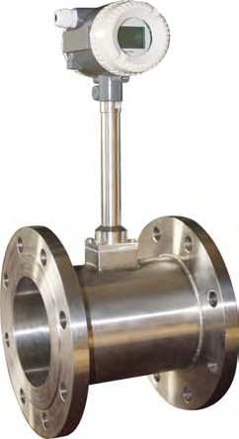

Vortex Flowmeter

Overview Overview

The vortex flowmeter is a velocity flowmeter made according to the Karman vortex theory, using the natural vibration principle of the fluid, and using piezoelectric crystals or differential capacitors as detection components.
This product adopts unique differential technology, with isolation, shielding, filtering and other measures to overcome the problems of poor shock resistance, large noise, and small signal data disorder of similar products, and adopts unique detection probe packaging new technology and protective measures to ensure Improve the reliability of the product.
The product has three measurement types: basic type, differential pressure type, and temperature and pressure compensation integrated type. The basic type measures the flow signal of a single working condition, the differential pressure compensation type directly measures the mass flow, and the temperature and pressure compensation type can measure temperature, pressure, and flow at the same time. The signal, after compensation, outputs the volume flow rate or mass flow rate under standard conditions. The product has two structural types: pipeline type and plug-in type, which can be displayed on site or transmitted over long distances. Each type has specifications for high temperature, high pressure, anti-corrosion, and explosion-proof, and there are integral and split structures to adapt to different measurements. Media and installation environment.
The instrument has a series of advantages such as wide range ratio, high accuracy, convenient installation and maintenance and wide media adaptability. It can be widely used in the process measurement and energy-saving management of various low-viscosity liquids, gases, steam and other single-phase fluids in petroleum, chemical, metallurgy, machinery, food, paper, medicine, and urban pipeline heating, water supply, gas and other industries.

Basic structure

- Flange
- 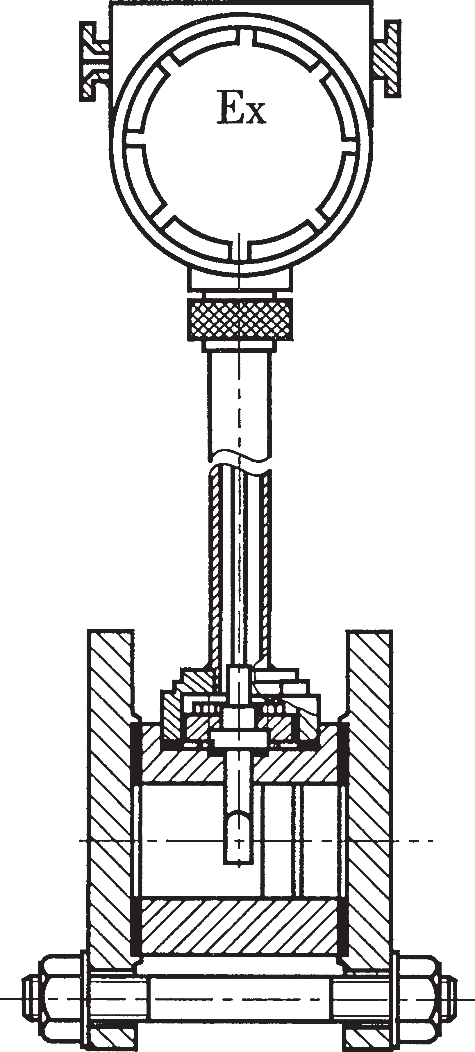Fastening bolt
- Body
- Vortex generator
- Detection probe
- Meter bar
- Lock nut
- Amplifier housing

Features

The structure is simple and firm, no moving parts, long service life, low pressure loss and low operating cost.
It adopts a new design of anti-mechanical vibration, anti-shock and anti-dirt structure.
From the detection probe to the operational amplifier circuit, a high degree of interchangeability and versatility is realized.
The circuit adopts surface mount technology, compact structure and high reliability.
The menu is set according to the general operating principles, and the Chinese character prompts are adopted, which is clear and intuitive, and the operation is simple.
Within a certain reynolds number range, the output signal is not affected by changes in the physical properties and composition of the measured medium. The meter coefficients are only related to the shape and size of the vortex generator. Generally, there is no need to re-calibrate the meter coefficients after changing accessories.
Using a fine and low-power 128×64 full dot matrix LCD display, it can display instantaneous flow and accumulated flow on-site, as well as compensate the measured temperature and pressure, and display rich and intuitive data.
It has a multi-point linear correction function, which greatly improves the measurement accuracy. After using the high-speed algorithm to measure the cycle of single pulse pulse by pulse, the output is only delayed by one cycle after the compression or expansion calculation is performed one by one, achieving complete real-time linear compensation, and this performance has reached the world's leading level.
The differential pressure compensation type vortex mass flowmeter can directly measure the mass flow, and is not affected by the change of the medium composition or dryness, and the measurement accuracy is higher.
The temperature and pressure compensation type built-in or external sensor automatically corrects the temperature and pressure, and directly converts the working condition flow into mass flow or volume flow under standard conditions. The measurement is simple and accurate. 12 compensation algorithms can almost meet all flow compensation requirements.

Technical Parameters

Measuring medium | Liquid, gas, steam
Nominal diameter | Flange mounting type: DN15~DN300  Flange connection type, pipe butt welding type: DN15~DN400 threaded connection type, clamp connection type: DN15~DN100 fixed plug-in type, ball valve plug-in type: DN200~DN2500
temperature range | Piezoelectric type: pipe type -20℃ ~ 350℃ plug-in type -10℃ ~ 300℃ capacitive type: pipe type -50℃ ~ 500℃ plug-in type -30℃ ~ 450℃
Pressure specification | 1.6Mpa , 2.5Mpa , 4.0 Mpa , higher pressure specifications can be customized
Range | Normal range 1 : 10 Expanded range 1 : 15
Quasi really degree | Liquid: ±1.0% of the indicated value  Gas, steam: ±1.5% of indicated value Insertion type: ±2.5% of indicated value
Heavy complex nature | ≤1 /3 of accuracy
Power supply | Pulse output type +12VDC , +24VDC (optional ) 4 ~ 20mA.DC current output type +24VDC  The on-site display instrument comes with 3.6V lithium battery, the service life is more than 2 years
Output signal | Pulse frequency signal 0.1 ~ 3000Hz (low ≤1V high ≥ 6V ) two-wire . 4 ~ 20mA.DC current signal (available with HART communications)  Three-wire system 4 ~ 20mA.DC current signal (with RS485 communication possible)
Environmental conditions | Ambient temperature: Ordinary type -30℃ ~ 60 ℃ Explosion-proof type -25℃ ~ 50 ℃ Field display type -10℃ ~ 50℃ Ambient humidity: relative humidity 5% ~ 85%  Atmospheric pressure: ( 86 ~ 106 ) KPa
Allow vibration acceleration | Piezoelectric type≤0.2g Capacitive type≤1.0g
Signal distance | Pulse signal≤500m Current signal≤1000m RS485 c o m m u n I c a t i o n ≤ 1200m
Signal line interface | Internal thread M20×1.5
Explosion-proof mark | Flameproof ExdⅡBT5 Intrinsically Safe ExiaⅡCT5
Protection level | Ordinary type IP65 diving type IP68
Instrument material | 1Cr18Ni9Ti , special materials can also be used according to user requirements.

The main dimensions of the product
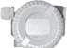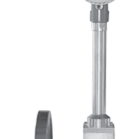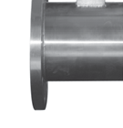

Nominal diameter | Instrument length | Instrument height  H | Mounting flange |  |  |  | Mounting bolt |  | Piping specifications
 |  |  | Flange  Outer diameter | Flange  thickness | Bolt hole pitch | Bolt aperture | Number of  bolts | Bolt specification

Note: 1. The above parameters are only applicable to flange connection type vortex flowmeters with pressure specifications below 1.6MPa

2. The length of the instrument is a standard size, and the length of the instrument with integrated pressure compensation is correspondingly extended by 50mm
3. Flange connection vortex flowmeters are not equipped with pipe flanges and bolts when they leave the factory. Users need to purchase them separately. The standard for connecting flanges is GB/T9119-2000 raised panel flat-welded steel pipe flanges.

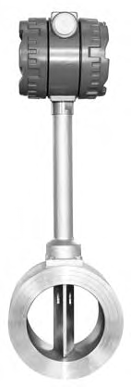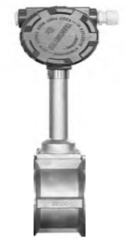

Nominal diameter DN | Instrument length  L | Installation length  L | Instrument height  H | Instrument outer diameter  D | Piping  specifications
15 | 80 | 116 | 400 | 68 | φ18×1.5
20 | 80 | 116 | 400 | 68 | φ25×2.5
25 | 80 | 116 | 400 | 68 | φ32×3.5
32 | 80 | 116 | 400 | 68 | φ39×3.5
40 | 80 | 116 | 404 | 80 | φ49×4.5
50 | 80 | 116 | 412 | 88 | φ59×4.5
65 | 80 | 116 | 428 | 105 | φ74×4.5
80 | 80 | 116 | 446 | 120 | φ89×4.5
100 | 80 | 118 | 472 | 148 | φ109×4.5
125 | 85 | 124 | 492 | 174 | φ134×4.5
150 | 90 | 135 | 515 | 196 | φ159×4.5
200 | 105 | 150 | 570 | 250 | φ219×9
250 | 120 | 166 | 620 | 300 | φ273×11
300 | 135 | 185 | 670 | 350 | φ325×12
Note:
1. The above parameters are only applicable to flange-mounted vortex flowmeters with pressure specifications below 2.5MPa .
2. The mounting flange is a special flange, which has been equipped before leaving the factory. The standard of the mounting flange is the corporate standard, and it is recommended to use it.

Description:

1. The above dimensions are only for reference when designing and selecting. The actual dimensions are subject to confirmation at the time of delivery or ordering.

2. The diameter of commonly used seamless steel pipes is the diameter of metric steel pipes. If imperial steel pipes are used, they must be specified when ordering.

3. The structural dimensions of the pipe butt welding type, threaded connection type, clamp connection type, fixed plug-in type, ball valve plug-in type, and the high temperature type and ultra-low temperature type are subject to confirmation at the time of delivery or ordering. 4. The installation flange of the flowmeter adopts the corporate standard or the national standard GB/T9119-2000 , and can also adopt other national department or industry standards, or adopt other national standards (American standard, German standard, Japanese standard, etc.) according to user needs, such as If you need special standards, please indicate when ordering.

Models and specifications

Vortex street flow amount meter type spectrum |  |  |  |  |  |  |  |  |  | Description
HLB HLE | Piezoelectric vortex flowmeter  capacitive vortex flowmeter |  |  |  |  |  |  |  |  | Instrument type
 | 2  3  4  5  6  7  8 | Flange clamp type  Flange connection type  Pipe butt welding type  Thread connection type  Clamp connection type  Fixed plug-in type  Ball valve plug-in type |  |  |  |  |  |  |  | Installation method
 |  | 2  3  4 | Liquid  Gas  Vapor |  |  |  |  |  |  | Measuring medium
 |  |  | -X | Flowmeter cnominal diameter with 2-4 Arabic numerals,  For example: DN200 with 200 represents |  |  |  |  |  | Nominal diameter
 |  |  |  | -2  -3  -4  -5  -6  -7  -8  -9 | Pulse frequency signal without display  Pulse frequency signal with display  Battery powered on-site display  Two-wire . 4 ~ 2 0mA signal without display .  Two-wire . 4 ~ 2 0mA signal with display .  Two-wire . 4 ~ 20mA signal with HART communication  Three-wire . 4 ~ 20mA signal with display  Three-wire 4 ~ 20mA signal with RS485 communication |  |  |  |  | output signal
 |  |  |  |  | 2  3  4  5  6 | -50℃～50℃（capacitive type only）  -20℃～50℃ 50℃～250℃  50℃～320℃  50℃～500℃（capacitive type only） |  |  |  | Temperature  specification
 |  |  |  |  |  | 2  3  4  5  6 | 1.6 Mpa  2.5 Mpa  4.0 Mpa  6.4 Mpa  Higher pressure specifications  ( up to 32 Mpa) |  |  | Pressure specification
 |  |  |  |  |  |  | M P T PT | Differential pressure compensation type Pressure compensation type Temperature compensation type  Temperature and pressure compensation type |  | Compensation type
 |  |  |  |  |  |  |  | F Q S  N G B Y | Sub body type  Diving type  Reduced -diameter type  Corrosion resistant type  Explosion-proof type  Intrinsically safe explosion-proof type  Integrated compensation type | Other option
HLE | 3 | 4 | -80 | -6 | 6 | 3 | M | Y | Integrated capacitive differential pressure vortex mass flowmeter, flange connection type, steam with medium less than 500℃ , DN80 , PN25 , current signal output with display.

Selection

The selection of a vortex flowmeter is a very important task. The correct selection is a prerequisite for the normal operation of the flowmeter. Statistics show that 70% of the failures of the flowmeter are caused by incorrect selection or improper installation. Therefore, the flowmeter must be selected correctly. The specific selection method can refer to the following:
1. Selection of instrument type
Piezoelectric vortex flowmeter has a series of advantages such as wide range ratio, high accuracy, convenient installation and maintenance and wide media adaptability, and it has good economical use. It is a commonly used flow meter at present.
Capacitive vortex flowmeters have all the advantages of piezoelectric vortex flowmeters, and also have high temperature tolerance, with a temperature adaptation range of -50°C to 500°C . Capacitive vortex flowmeter signal processing adopts advanced digital spectrum technology to adapt to various measurement media, has a lower measurement limit, superior anti-interference and shock resistance, and realizes ready-to-install and use, adjustment and maintenance-free.
2. Choice of installation method
Flange mounting is the preferred installation method because of its compact structure, easy installation, and short delivery period, which is suitable for most applications. Flange connection types are mostly used for integrated differential pressure, temperature, pressure compensation vortex flowmeters and some special applications.
Pipe butt welding type and clamp connection type are suitable for high pressure media, among which the clamp connection type can be disassembled. The threaded connection type is mainly used for small-caliber, food-grade hygiene requirements.
Plug-fixed, ball-type insert for large diameter, generally choose a fixed plug -in, easy installation, lower cost; case can continue to plug-flow ball valve repair, used for dirty media, easy to scale, of requiring regular cleaning.
3. Determination of the measuring range
The measuring range of vortex flowmeters of different calibers is different, even if the same caliber flowmeter is used in different media, its measuring range is also different. The actual usable measurement range must be determined by calculation. The following table provides the flow range of three typical media under specific conditions.
Reference table for range of pipeline flowmeter flow

DN(mm) | 15 | 20 | 25 | 32 | 40 | 50 | 65
Water | 1.2-6.2 | 1.5-10 | 1.6-16 | 1.9-19 | 2.5-26 | 3.5-38 | 6.2-65
Air | 5-25 | 6-50 | 9-80 | 13-130 | 18-180 | 30-300 | 48-480
Steam | 5.8-30 | 6.5-55 | 10-100 | 15-150 | 22-220 | 50-500 | 75-750
DN(mm) | 80 | 100 | 125 | 150 | 200 | 250 | 300
Water | 10-100 | 15-150 | 25-250 | 36-380 | 62-650 | 140-1400 | 200-2000
Air | 75-750 | 120-1200 | 150-1500 | 260-2600 | 450-4500 | 680-6800 | 1000-10000
Steam | 120-1200 | 190-1900 | 280-2800 | 450-4500 | 800-8000 | 1200-12000 | 1800-18000

Reference table for flow range of plug-in flowmeter
DN(mm) | 200 | 250 | 300 | 350 | 400 | 450
Water | 70-700 | 110-1100 | 180-1800 | 210-2100 | 270-2700 | 350-3500
Air | 600-6000 | 1060-10600 | 1500-15000 | 2000-20000 | 2700-27000 | 3300-33000
Steam | 680-6800 | 1100-11000 | 1700-17000 | 2400-24000 | 3200-32000 | 4000-40000

DN(mm) | 500 | 600 | 800 | 1000 | 1200 | 1500
Water | 450-4500 | 600-6000 | 800-8000 | 1200-12000 | 1800-18000 | 2600-26000
Air | 4200-42000 | 6100-61000 | 11000-110000 | 17000-170000 | 24000-240000 | 38000-380000
Steam | 5200-52000 | 7100-71000 | 13000-130000 | 20000-200000 | 28000-280000 | 42000~420000
The above flow range is the data that three typical media adapt to under specific conditions:
The liquid medium is water: T=20℃ ρ=999.8 Kg/m 3 μ=1.0cp
The gas medium is air: T=20℃ P=101.325kPa (absolute pressure) ρ=1. 293 Kg/m 3 μ=0.084cp
The steam is superheated steam: T=188℃ P=0.48 MPa (absolute pressure) ρ=2.277 Kg/m 3 μ=0.015cp
The upper limit flow of the vortex flowmeter is generally not affected by the density and kinematic viscosity of the medium, while the lower limit flow depends on the density and kinematic viscosity of the medium. Therefore, determining the flow range is actually to determine the actual available lower limit flow. When the medium is not measured via three typical when a typical working conditions substance or medium change, should be corrected according to the actual value of the lower limit flow density and viscosity.
Density correction Viscosity correction

Where:
Q 1 , Q 2 - the measurable lower limit flow rate of the measuring medium after density and viscosity correction, m ³/h Q 0 - the lower limit flow rate of the typical medium, m ³ /h
ρ ₀ , ρ- working density of typical medium and measuring medium, Kg/m ³
μ 0 , μ- dynamic viscosity of typical medium and measuring medium, CP

When Q ₁ ＞Q ₂ , the flow range of the measurable working condition and the flow range of the linear working condition are both Q ₁ ~ Qmax ;
when Q ₁ ≤ Q ₂ , the flow range of the measurable working condition is Q ₁ ~ Q_{max} , the flow range of the linear working condition Is Q ₂ ~Qmax;
Qmax is the upper limit flow rate of a typical medium.

4. Selection of nominal diameter
The selection of the nominal diameter must first determine the volume flow range of the measuring medium under working conditions, and then calculate the actual measurable flow range of the piping diameter. If the flow range of the measured medium is within the actual measurable flow range of the corresponding caliber, select a flowmeter with the same caliber as the piping; if the actual measurable flow range of the corresponding caliber cannot meet the requirements of the lower limit flow rate, reduce it Caliber, recalculate; if the actual measurable flow range of the corresponding caliber cannot meet the requirements of the upper flow rate, increase the caliber and recalculate.
If you only know the mass flow rate of the measuring medium or the volume flow rate under standard conditions, you should first convert it to the volume flow rate under the working condition, and then compare it with the calculated actual measurable flow rate range.
The volume flow under the working conditions converted from the mass flow is calculated by the following formula:
Q = M/ρ

Where: Q— volume flow rate under working conditions, m ³ /h
M— mass flow rate, Kg/h
ρ— medium density under working conditions, Kg/m ³

The volume flow under the standard working condition to calculate with the following formula:

Where: Q_{b} - volume flow rate under standard conditions, m³ /h
P- working pressure of the medium, gauge pressure MPa
T- working temperature of the medium, ℃
If the working density and kinematic viscosity of the measured medium are not much different from the three typical mediums, you can directly look up the table to select the appropriate one without calculation of nominal diameter; If the working density and kinematic viscosity of the measuring medium are very different from the three typical mediums, such as hydrogen with very low density and oil with high viscosity, the vortex flowmeter is probably not applicable and must be carefully calculated measurable flow range.
5. Selection of compensation type
The vortex flowmeter measures the volume flow under working conditions. If you need to measure the standard flow or mass flow, you need to compensate. The compensation methods include differential pressure compensation, pressure compensation, temperature compensation, temperature and pressure compensation.
The differential pressure compensation type vortex mass flowmeter is a milestone product developed by our company's research and development team after years of painstaking research. It is the first in the world and has obtained a national patent. It is a true vortex mass flow. meter. Traditional vortex flowmeters use the method of setting density or temperature and pressure compensation density to calculate the mass flow of the measured medium, and this density will change due to the change of the medium composition or dryness, simply by setting the density Or the method of temperature and pressure compensation can not reflect this change, thus producing technical errors. The differential pressure vortex mass flowmeter developed by our company uses the functional relationship between differential pressure and density, and calculates the density by measuring the differential pressure. This measurement scheme is not affected by changes in medium composition or dryness, and is especially suitable for Metering of mixed gases, liquids, steam and water vapor with unstable components.
The temperature-compensated vortex flowmeter is suitable for measuring the mass flow of saturated steam with relatively stable pressure; the pressure-compensated vortex flowmeter is suitable for measuring the standard flow of gas with little temperature change and the mass flow of saturated steam; temperature, pressure Compensation type vortex flowmeter is suitable for measuring the mass flow of steam and the standard flow of gas, with higher compensation accuracy.
6. Other types of options
The split vortex flowmeter is used for installation in humid environment or high temperature occasions. The circuit part and the sensor are installed separately to avoid the influence of harsh environment on the detection circuit.
The submersible vortex flowmeter adopts a special waterproof technology, and the protection level is IP68 . It can work underwater for a long time and is suitable for occasions with a risk of flooding .
The reduced-diameter vortex flowmeter has a lower flow measurement lower limit, which is suitable for occasions where the medium flow is low and it is inconvenient to shrink the tube.
The integrated compensation type vortex flowmeter integrates the compensation equipment and the flowmeter into a part of the flowmeter. This design is more integrated and easier to install, but the production cost is also higher.
Corrosion-resistant vortex flowmeter is used to measure media that is corrosive to 304 stainless steel. The meter body is made of corresponding corrosion-resistant materials. When the measuring medium is corrosive gas or liquid, specific requirements and installation should be provided in advance The material of the pipe.
Intrinsically safe explosion-proof and flame-proof vortex flowmeters are used in explosion-dangerous occasions. Intrinsically safe explosion-proof flowmeters are recommended. Because explosion-proof instruments are not allowed to be used in Class O hazardous occasions, and explosion-proof instruments are not allowed on site. Open the shell to adjust the circuit when energized; the advantage of the flameproof instrument is that it is easy to install, does not need to be equipped with a safety barrier, and is low in cost . For general hazardous situations, flameproof type can be selected.
After completing the selection of the above items, selecting other parameters against the type spectrum table, and combining the codes in the specified order, the model of the vortex flowmeter can be obtained.

